**Project Design Phase-II**

**Technology Stack (Architecture & Stack)**

|  |  |
| --- | --- |
| Date | 29 October 2022 |
| Team ID | PNT2022TMID07525 |
| Project Name | Project – IOT based smart irrigation system |
| Maximum Marks | 4 Marks |

**Technical Architecture:**

Control section

Open Weather API

**input**

IBM Cloud

Node Red

Farmer

Moisture section

IOT section

**Motor**

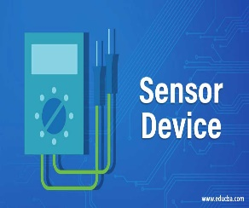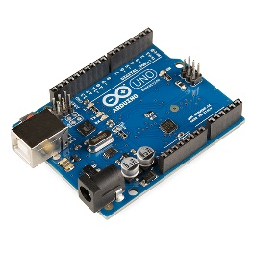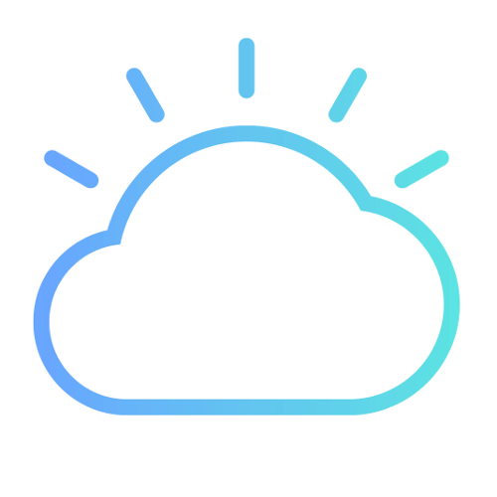

**SENSORS ARDUINO PYTHON IBM CLOUD**

 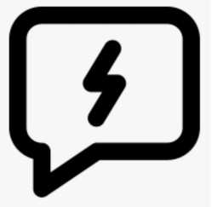

**AUTHORITIES WEB UI MOBILE APP FAST SMS**

**Table-1 : Components & Technologies:**

|  |  |  |  |
| --- | --- | --- | --- |
| **S.No** | **Component** | **Description** | **Technology** |
| 1. | Received data from sensors | The information gathered from the senor installed on the fields | ESP32 wi-fi module |
| 2. | Web interface | The gathered information was presented visually | HTML,CSS,JavaScript |
| 3. | Database | Datatype | MySQL |
| 4. | Cloud database | Cloud database service | IBM cloud |
| 5. | Data storage | Storage needs for files | IBM Block storage |

**Table-2: Application Characteristics:**

|  |  |  |  |
| --- | --- | --- | --- |
| **S.No** | **Characteristics** | **Description** | **Technology** |
| 1. | Moisture level monitoring | By putting moisture sensors in the fields, it is possible to check the moisture level of the soil. | YL69-sensor |
| 2. | Moisture monitoring | You can check the Moisture of soil. | Moisture sensor |
| 3. | Pollution monitoring | To check the ph of soil. | Conductive sensor |